INTI International College Penang School of Computing
3+0 Bachelor of Science (Hons) in Computer Science, in collaboration with Coventry University, UK 3+0 Bachelor of Science (Hons) in Computing, in collaboration with Coventry University, UK

Coursework cover sheet

Section A - To be completed by the student.

Full Name: Desmond Kok Weng Hin
CU Student ID Number: 14196612
Semester: First semester
Session:
April 2023
Lecturer:
Puteri Nursyawati Azzuri (puteri.azzuri@newinti.edu.my)
Module Code and Title:
4067CEM Software Design
Assignment No. / Title: Prototype User Interface and Usability Testing  Continuous Assessment | % of Module Mark:  50
Hand out Date:  12 May 2023 | Due Date:  Task 1: 02 June 2023, by 11.59pm.  Task 2: 07 July 2023, by 11.59pm  Task 3: 23 June 2023, by 11.59pm.  Task 4: 23 June 2023, by 11.59pm.  Task 5: 23 June 2023, by 11.59pm.
Penalties: No late work will be accepted. If you are unable to submit coursework on time due
to extenuating circumstances, you may be eligible for an extension. Please consult the lecturer.
Declaration: I/we the undersigned confirm that I/we have read and agree to abide by the University regulations on plagiarism and cheating and Faculty coursework policies and procedures. I/we confirm that this piece of work is my/our own. I/we consent to the appropriate storage of our work for plagiarism checking.

Signature(s):

Section B - To be completed by the module leader

Intended learning outcomes assessed by this work:
- Understand and apply appropriate concepts, tools, and techniques to each stage of the software development.
- Understand and apply design patterns to software components in developing new software.
- Demonstrate an understanding of project planning and working to agreed deadlines, along with professional, interpersonal skills and effective communication required for software production.
5. Demonstrate an awareness of, and ability to apply, social, professional, legal, and ethical standards as documented in relevant laws and professional codes of conduct such as that of
the Malaysian National Computer Confederation.
Marking scheme | Max | Mark
1. User Story Mapping | 20
2. Setting up a GitHub
Repository | 10
3. Creating a Class diagram and
design pattern selection | 30
4. Creating a Prototype User
Interface and Usability Testing | 20
5. Discuss the ethical issue
related to the software | 20
Total | 100

The 4067CEM assessment should be completed as a full individual work over the course of the module. The assessment output are only judged at the end of the module and not by the expectations during that week. The assessment should be undertaken individually. All submissions will be checked against each other and the internet for possible plagiarism.

Activities – These activities consist of 50% of your coursework marks. It will be run throughout the semester and there will be a final submission at the end of the semester. These activities consist of activities that will be done in a software design phase.

System

Student Business System for College.

Task 1 – User Story Mapping (20 marks)

The first thing that you need to do is ask the user what they wished for in a system. The user here can be your friends as the system is related to them. Get at least 10 real users to get their feedback. Document their feedback. Use software like Trello to complete this activity.
Output – All the user stories, and backlog with goals, activities, and tasks. In Word format, uploaded it to GitHub.
Due – Week 9 of the semester. 02 June 2023, by 11.59 pm.

Task 2 – Setting up a GitHub Repository (10 marks)

This is where the output of the tasks will be stored, Make sure you register an account, create a repository and your files are uploaded here and it is in an organized manner and can be easily found.
Output – GitHub Repository with Task 1, Task 3, Task 4 and Task 5 documents. Take note the date of the files will be shown so you must follow the due date of each task.
Due – It will be accessed on Week 14 of the semester. 07 July 2023, by 11.59 pm

Task 3 – Creating a Class diagram and design pattern selection (30 marks)

Create a simple Class diagram which should consists of the Classes that might be used to represent the system and the association between them. You don’t have to declare the attributes and operations for this activity. You do have to explain the class responsibility of each class declared. You can use software like StarUML to complete this activity.
Output – A class diagram containing classes and associations. In Word format, uploaded it to GitHub.

Consider the problem and select a suitable design pattern that can be implemented on the problem. Give justification on why the design pattern was chosen. Draw the UML diagram representing your class diagram as a design pattern UML. Include all the abstract class/interface, concrete class, and inheritance (if any) used to represent the problem.
Output – UML diagram representing the design pattern. In Word format, uploaded it to GitHub. Due – Week 12 of the semester. 23 June 2023, by 11.59 pm.

Task 4 – Creating a Prototype User Interface and Usability Testing (20 marks)

Create a Prototype User Interface (hand drawn/digital) of TWO (2) important functions of the proposed system. Come up with usability testing questions. You don’t have to carry out the test, just prepare the questions. You should indicate what you are testing for in the Usability Testing.
Output – A Prototype and Usability Testing Questions. In Word format, uploaded it to GitHub. Due – Week 12 of the semester. 23 June 2023, by 11.59 pm.

Task 5 – Discuss the ethical issue related to the software (20 marks)

Discuss and do a critical analysis of your software in these areas, privacy concerns, intellectual property rights, and effects on society.
Output – A report in Word format, uploaded to GitHub.
Due – Week 12 of the semester. 23 June 2023, by 11.59 pm.

Submission

All tasks needed to be documented in Word format and submitted for SafeAssign checking (Links will be provided before the due date).
Upload the document and the SafeAssign report to your GitHub repository by each task due date. Due – It will be accessed on Week 14 of the semester. 07 July 2023, by 11.59 pm

Marking Rubric for Continuous Assessment

 | Marks Below 40% | Marks in the range 40 – 49% | Marks in the range 50 – 59% | Marks in the range 60 – 69% | Marks 70% and above
User Story | User Story Mapping | User Story Mapping | User Story Mapping | User Story Mapping | User Story Mapping done and does capture most important activities of the system. The breakdown of the user story mapping is excellent and uses software that can assist that process (For example Trello compared to Ms.  Word).
Mapping | not done or User | done at a minimum | done and does | done and does
(20 marks) | Story copied/does  not match the exact | level and does not  capture the | capture several  important activities of | capture several  important activities of
 | system. | important activities of | the system. The | the system. The
 |  | the system. | breakdown of the | breakdown of the user
 |  |  | user story mapping | story mapping is good
 |  |  | can be improved. | and uses software that
 |  |  |  | can assist that
 |  |  |  | process (For example
 |  |  |  | Trello compared to
 |  |  |  | Ms. Word).
Setting up a | GitHub repository | GitHub repository | GitHub repository | GitHub repository exist | GitHub repository
GitHub | does not exist or | exist and some of | exist and most of the | and all of the required | exist and all of the
Repository | cannot be accessed | the required files are | required files are | files are available at | required files are
(10 marks) | or the required files  are not available at | not available at the  time of access. | available at the time  of access. However | the time of access.  However the dates for | available at the time  of access. The dates
 | the time of access. |  | the dates does not | some files does not | on the files follows
 |  |  | follow the required | follow the required | the required
 |  |  | deadline. | deadline. | deadline.
Creating a | The Class diagram | The Class diagram | The Class diagram | The Class diagram | The Class diagram
Class diagram | does not represent | and design pattern | and design pattern | and design pattern | and design pattern
and design pattern selection (30 marks) | the required solution (contains generic or non- related classes  such as admin), the design pattern | represent the required solution but in a very general and incomplete way.  Required classes in | represent the required solution in a partial way. A few  required classes in the design are not | represent the required solution in a satisfactory way. Most  required classes are declared. | represent the required solution in an excellent way. All  required classes are declared.
 | suggested is not | the design are not | declared.
 | suitable for the given | declared.
 | problem.

Creating a Prototype User Interface and Usability Testing  (20 marks) | No prototype were available or the measurement for the usability testing is not clear. | The prototype cover minimalist and trivial design (such as login) and the measurements for the usability testing are not clear. | The prototype cover adequate design and several measurements for the usability testing are not clear. | The prototype cover good design and most measurements for the usability testing are clear. | The prototype cover excellent design and all measurements for the usability testing are clear.
Discuss the ethical issue related to the software  (20 marks) | There is no discussion on the ethical issue or only the theories are pasted back for this component. | There is an attempt to discuss on the ethical issue but no critical  analysis was done | There is an attempt to discuss on the ethical issue with some critical analysis was done | There is an attempt to discuss on the ethical issue with good critical analysis. | There is an attempt to discuss on the ethical issue with excellent critical analysis.

Task 4
4.1 Prototype of updating profile function
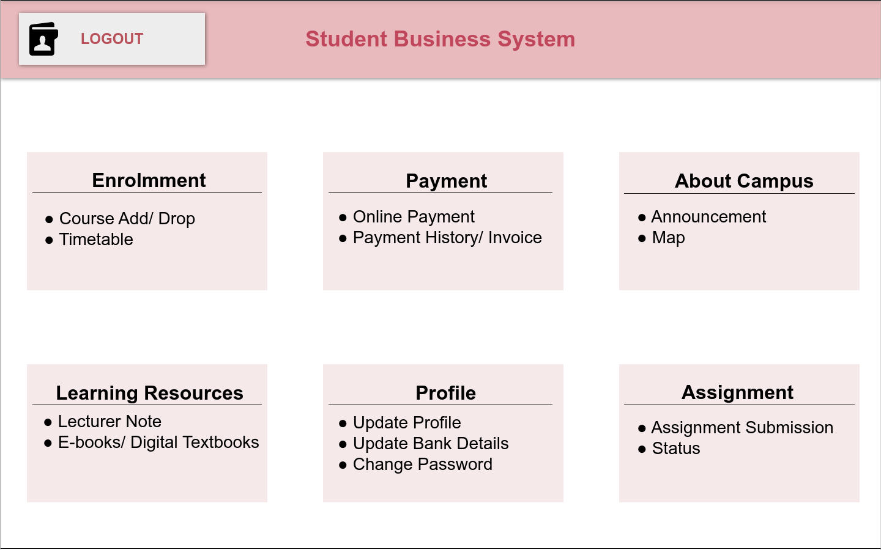
Diagram 1.1 (A) Main Page of Student Business System
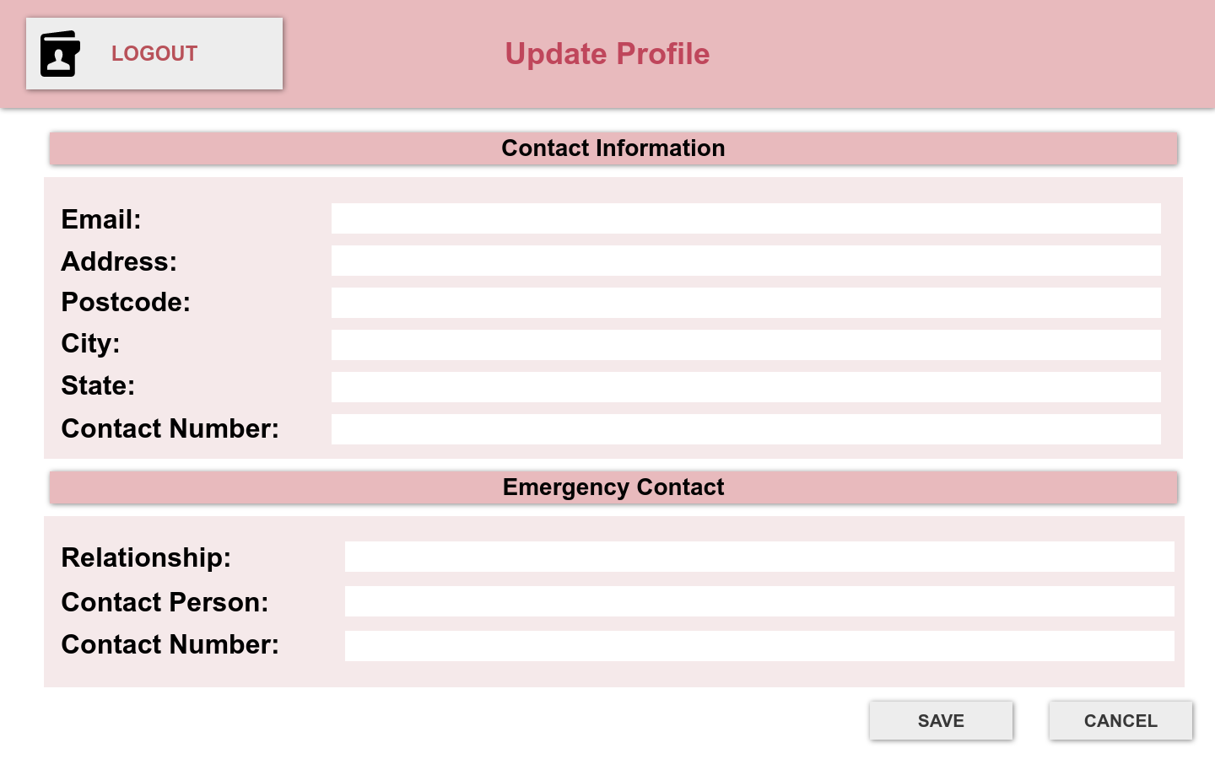
Diagram 1.1 (B) Profile update page
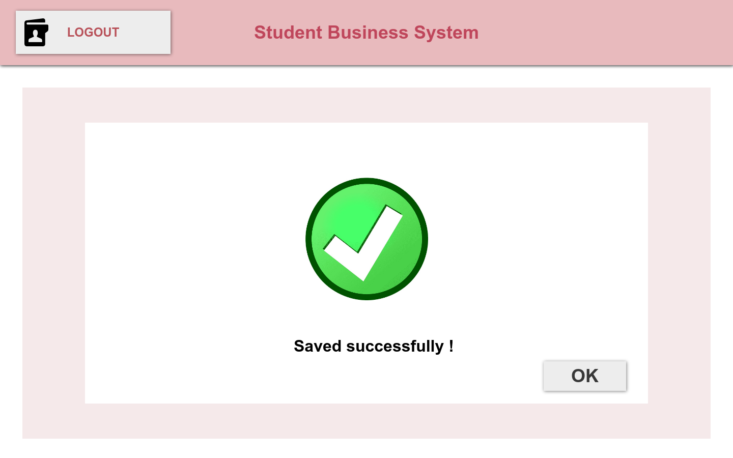
Diagram 1.1 (C) Profile Update Confirmation Page

4.2 Function of updating personal information
The function of updating personal information has shown in diagram 1.1. Students can easily update their profile information using the “update profile" function within the student business system.
Firstly, students can click on the “Update Profile” option located in the “Profile” category on the main page of the system which is shown in Diagram 1.1 (A). By taking this step, they will be taken to a page for updating their profile. On this “Profile Update” page, which has shown in diagram 1.1 (B), students can edit their contact information including email, full address and phone number. They also have the option to update their emergency contact if needed. Once they have changed everything as they want, they can click the “Save” button to finalize the updates
After successfully saving the updated personal information, a message will be displayed on the screen as shown in the diagram 1.1 (C) to confirm that the changes have been saved successfully.

Usability testing question
- Is it simple to locate the option for updating your personal information?
- Did you encounter any difficulties or confusion while trying to update your personal details?
- Were you able to find and access any additional personal information management settings or options?
- Did the process of changing your personal information involve any unnecessary or redundant steps?
- Do you find the instructions provided to be clear and easy to follow when updating your personal information?
- Was the process of updating your personal information clear and intuitive?
- Were there any error messages or validation issues that you encountered while updating your personal details?
- Did you encounter any issues or error messages while updating your personal details?
- Were the labels provided clear and easy to understand?
- How satisfied are you with the overall usability of the personal information update feature?
- Were the fields for editing the emergency contact information easy to locate?
- Did you encounter any difficulties in navigating to the “Update Profile” option within the system?
- Were there any delays or lagging while accessing the “Profile Update” page?
- Did you come across any issues related to the “Save” button functionality ?
- Are you satisfied with the overall design and layout of the “Profile Update” page?

4.3 Prototype of course registration function

Diagram 1.2 (A) Main Page of Student Business System
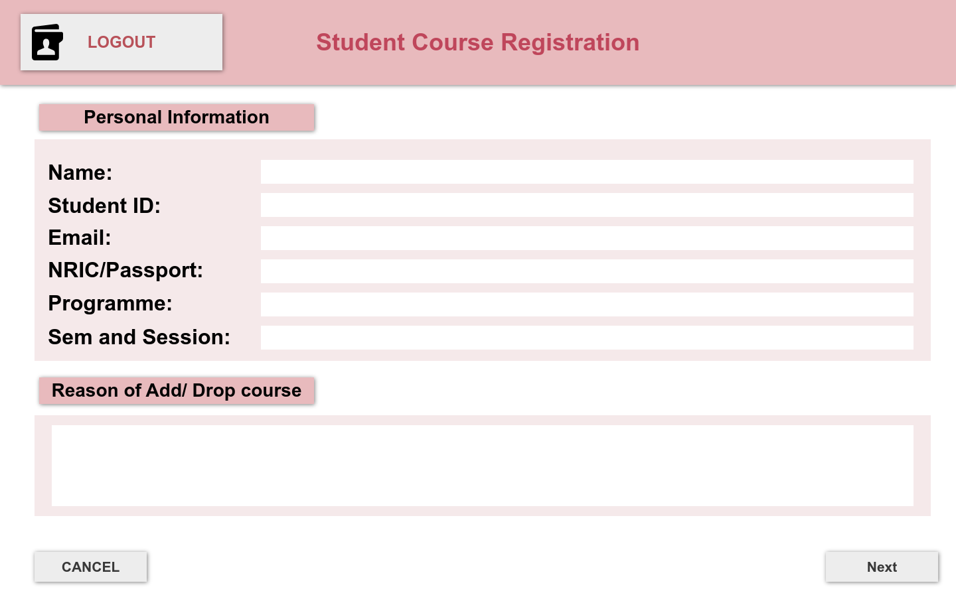
Diagram 1.2 (B) Pre-Registration Information Page

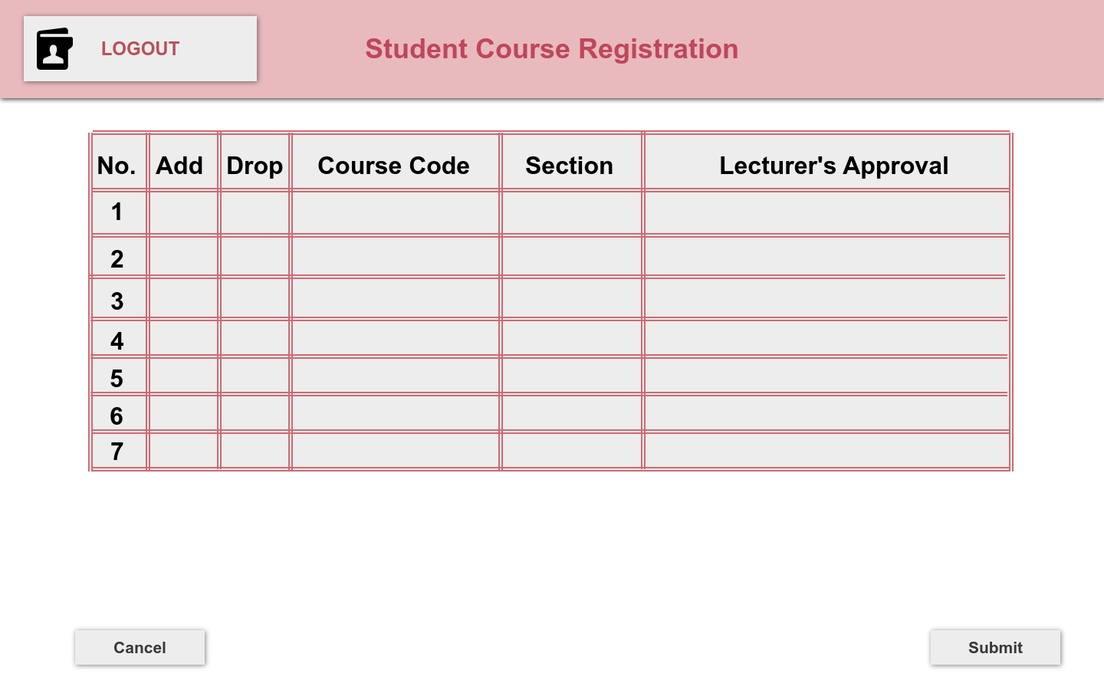
Diagram 1.2 (C) Course Registration Page
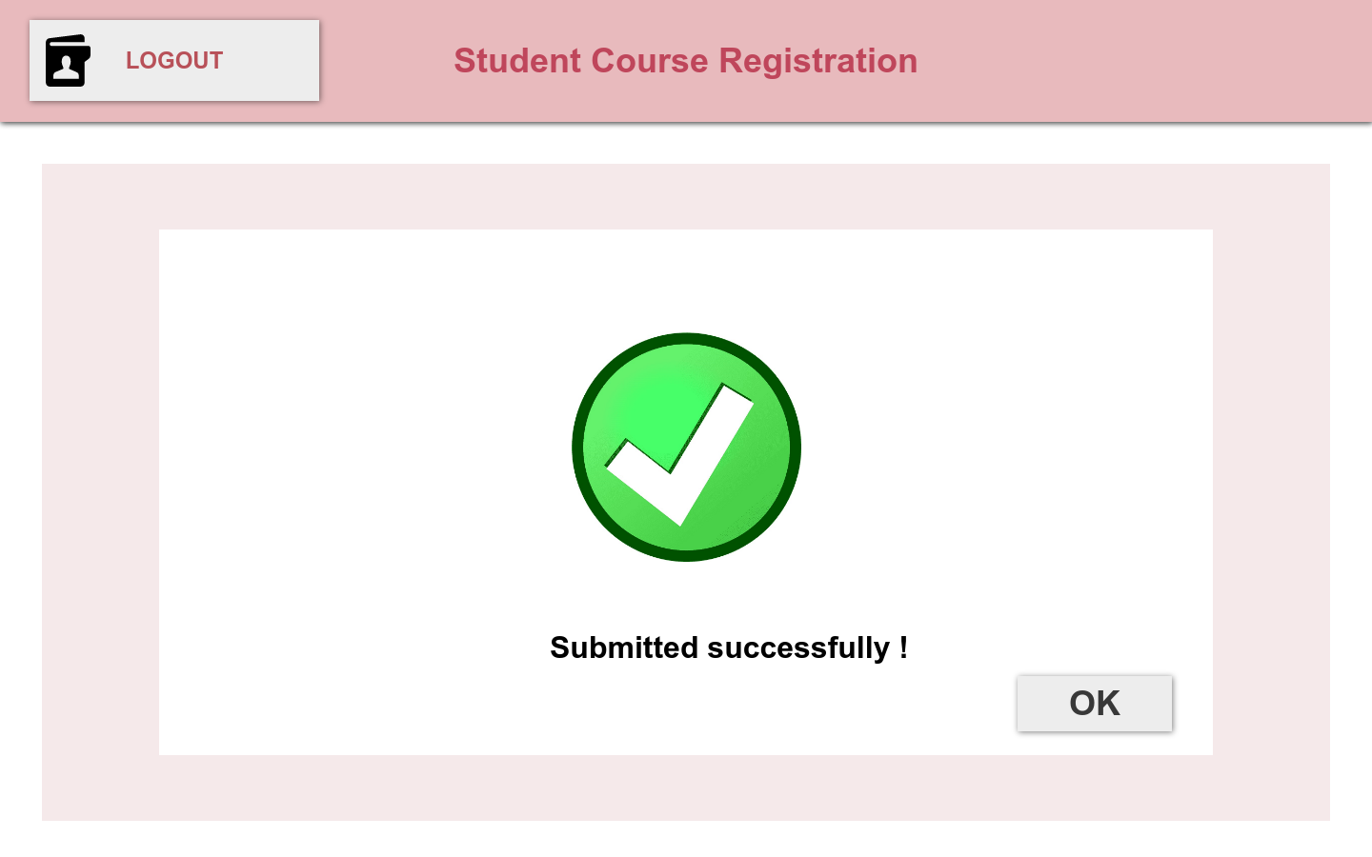
Diagram 1.2 (D) Submission Successful Page
4.4 Function of courses registration
The function of courses registration has been shown in diagram 1.2. Students can add or drop courses using the “Course add/drop” option located in the “Enrolment” category on the main page of the system (refer to Diagram1.1 (A)). By clicking on this option will navigate them to the pre-registration information page which is shown in Diagram 1.2 (B).
On this page, students are required to fill in various fields, including personal information such as their name, student ID, email, NRIC, programme, semester and session before proceeding to the course registration page. Additionally, students need to provide a reason for dropping or adding the course. The purpose of this page is to simplify the course registration by collecting important information ahead of time. Once students have done filling in all the information, they can click on “Next” button to navigate to the course registration page.
On the course registration page as shown in the diagram 1.2 (C), students have the flexibility to add or drop courses by entering the course code and section. Students can obtain the course code from their Head of Programme (HOP). After entering all the information, students can click the “Submit” button and wait for HOP’s approval. Once the approve is granted, the “Lecturer’s Approval” status will display a message “Approved”.
Lastly, it will show a submission successful page which shown in the diagram 1.2 (D).

Usability testing question
- Was the process of course registration easy to navigate and understand?
- Did you encounter any issues or confusion when navigating to the course registration page?
- Did you face any challenges in fill in the course code you were interested in?
- Did the course descriptions and provided details offer enough information for you to make decisions?
- Did you encounter any difficulties in understanding the prerequisites or requirements for certain courses?
- Was it effortless for you to add or remove courses from your registration list?
- Did you encounter any errors or issues during the submission of your final course registration.
- Were you provided with a clear notification after successfully submitting your course registration?
- Were there any specific features or enhancements that you would suggest to improve the course registration experience?
- How satisfied are you with the overall usability of the course registration feature?
- Were there any challenges or confusion when fill in the courses code?
- Did you encounter any problem when entering the reason of add or drop course?
- Were there any delays or lagging when submitting your course registration?
- Were there any challenges when entering the reason for adding or dropping a course?
- Did you encounter any problems when reviewing your final course registration before submission.

